INTRODUCTION:
VoteSecure is a web-based voting management system that integrates facial recognition technology to enhance election security, prevent voter fraud, and streamline the voting process. Traditional voting methods, whether paper-based or electronic, often face challenges such as voter impersonation, multiple voting attempts, long queues, and administrative inefficiencies. Even in online voting systems, security vulnerabilities and lack of strong identity verification measures pose risks to election integrity. VoteSecure addresses these concerns by ensuring that each vote is cast only once by a properly authenticated voter, eliminating the possibility of duplicate or fraudulent votes. Facial recognition technology, powered by artificial intelligence (AI) and machine learning (ML), provides a highly reliable biometric authentication mechanism. Unlike traditional ID-based verification, which can be forged or manipulated, facial recognition offers a secure, non-intrusive, and user-friendly way to verify voter identities. The system captures and matches a voter's facial features against a pre-registered database, allowing only eligible voters to access the platform. VoteSecure is designed to provide a transparent, efficient, and accessible election process. It minimizes human intervention in voter verification, reducing errors and speeding up the voting process. The system also ensures that votes are securely stored in an encrypted database, preventing unauthorized access or manipulation. Additionally, real-time vote counting and result computation improve election transparency and reliability. This project has broad applications, including government elections, university student council elections, corporate decision-making, and online polls requiring verified participation. By leveraging advanced technologies, VoteSecure aims to modernize the voting system, increase voter confidence, and enhance democratic participation while maintaining high security and accuracy standards.

PROBLEM STATEMENT:

Traditional voting systems, whether paper-based or electronic, suffer from several critical issues, including identity fraud, long waiting times, and human errors in voter verification. Manual verification processes are time-consuming and prone to mistakes, leading to inefficiencies and delays in elections. While digital voting solutions have emerged as an alternative, many still lack robust security measures, making them vulnerable to impersonation, hacking, and unauthorized access. VoteSecure addresses these challenges by integrating facial recognition technology to verify voter identities accurately and securely. By eliminating the possibility of multiple voting attempts and fraudulent activities, the system ensures that each vote is cast only by the rightful voter. This not only enhances the credibility of elections but also improves accessibility, efficiency, and transparency in the voting process.

HARDWARE AND SOFTWARE REQUIREMENTS:

Hardware Requirements:
- Server with a high-performance processor
- Web Camera for facial recognition
- Storage for database management
- Internet connectivity

Software Requirements:
- Frontend: HTML, CSS, JavaScript
- Framework: React.js
- Backend: Django
- Database: MongoDB
- Facial Recognition: OpenCV,
- API Integration: RESTful APIs for communication.

LITERATURE SURVEY:

A review of existing voting systems highlights significant challenges related to security, voter authentication, and accessibility. Traditional voting methods, such as paper ballots and electronic voting machines, rely on manual ID verification, which can be easily forged or manipulated, leading to identity fraud and multiple voting attempts. Although digital voting platforms have been introduced to improve efficiency, many of them lack strong authentication mechanisms, making them vulnerable to cyber threats, hacking, and unauthorized access. Biometric authentication, particularly fingerprint and facial recognition, has gained attention as a reliable method for secure identity verification. However, fingerprint-based systems require physical contact, which may pose hygiene concerns and accessibility issues. On the other hand, facial recognition technology has advanced significantly with the integration of AI and deep learning, offering a non-intrusive, fast, and highly accurate way to authenticate users. Research studies have shown that AI-powered facial recognition can achieve over 99% accuracy in identity verification, making it a suitable and secure solution for voting applications. By leveraging these advancements, VoteSecure aims to enhance election security, eliminate fraudulent activities, and ensure a seamless voting experience.

OBJECTIVE OF THE PROPOSED WORK:
  - Develop a secure web-based voting system with facial recognition: The system will utilize AI-powered facial recognition to authenticate voters, ensuring a highly secure and reliable voting process while eliminating the risks associated with manual verification.
  - Prevent duplicate or fraudulent votes: By verifying each voter's identity through facial biometrics, the system ensures that no individual can vote more than once, effectively eliminating impersonation and election fraud.
  - Ensure easy access to the system while maintaining high security: The platform will be designed with a user-friendly interface, allowing voters to participate effortlessly while incorporating encryption and authentication protocols to safeguard voter data.
  - Provide real-time monitoring and result computation: The system will enable election officials to track voting activities in real time and automatically compute results, ensuring a transparent and efficient election process.
  - Maintain an auditable log of votes for transparency: Every voting transaction will be securely logged in an encrypted database, allowing for post-election audits and verification to enhance trust and credibility in the voting process.

DATA FLOW DIAGRAM:

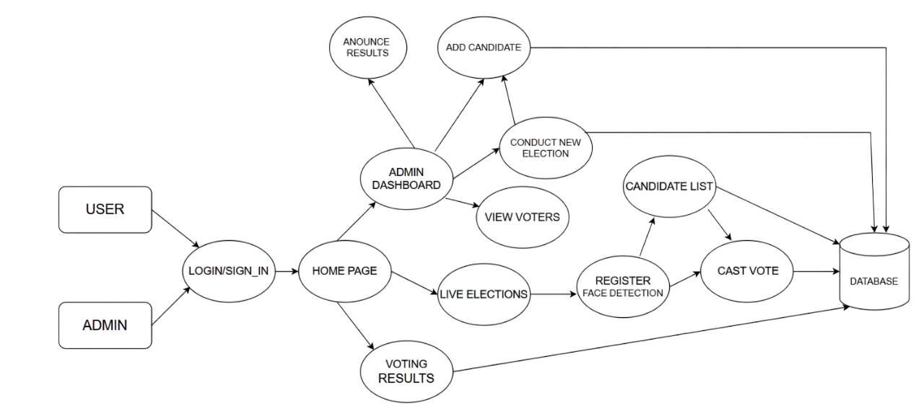

Fig 1: Data Flow Diagram of VoteSecure WebApp

PROPOSED METHODOLOGY:

- User Registration: Voters register on the platform by providing their personal details and capturing their facial scan, which is securely stored in the database for future authentication.

- Facial Recognition Authentication: During the voting process, the system verifies the voter's face against the stored facial data using AI-powered recognition to ensure only registered voters can access the system.

- Vote Casting: Once authentication is successful, the voter is granted access to cast their vote securely through the web application, ensuring a seamless and fraud-free voting experience.

- Database Management: All votes are encrypted and securely stored in the database, preventing unauthorized modifications, ensuring data integrity, and allowing future audits if needed.

- Result Computation: Votes are counted in real time, providing instant and transparent election results while minimizing manual errors and reducing the time required for result declaration.

EXPECTED OUTCOME OF THE PROPOSED WORK:
The development of a secure and efficient WebApp-based voting management system utilizing facial recognition aims to revolutionize the election process by ensuring transparency, preventing voter fraud, and enhancing the overall integrity of digital voting.
- A highly secure and fraud-resistant voting system: By implementing facial recognition, the system ensures that only registered voters can cast their votes, effectively eliminating impersonation and fraudulent activities.
- Faster and more efficient voting processes: The automated authentication and vote-casting mechanism streamline the voting process, reducing waiting times and making elections more efficient.
- Reduced human intervention, minimizing errors: The system automates voter verification and vote counting, significantly lowering the chances of human errors that often occur in manual voting processes.
- Greater trust in digital voting systems through transparent results: Real-time vote counting, encrypted data storage, and audit logs enhance transparency, ensuring that election outcomes are accurate and trustworthy.
- Improved accessibility for remote and differently-abled voters: Online voting with facial recognition allows eligible voters to participate from remote locations and provides an inclusive solution for those with physical disabilities.
- Elimination of paper-based voting, promoting eco-friendliness: By digitizing the election process, the system reduces the reliance on paper ballots, contributing to environmental sustainability.
- Scalability for large-scale elections: The system can be adapted for various election sizes, from small organizational polls to nationwide elections, ensuring flexibility and efficiency.
- Enhanced data security and voter privacy: Secure encryption and authentication measures ensure that voter data remains protected, maintaining confidentiality and preventing unauthorized access.

In summary, VoteSecure will serve as a crucial platform for ensuring secure and transparent elections by leveraging facial recognition technology. Its robust authentication process will prevent voter fraud, streamline the voting experience, and enhance trust in digital elections, ultimately benefiting both voters and election administrators.

APPLICATION:
- Government Elections: VoteSecure can be implemented in local, state, and national elections to enhance security, prevent voter fraud, and ensure a transparent and efficient electoral process.
- University and Corporate Elections: The system can be used for student council elections, faculty voting, and corporate decision-making processes, eliminating the need for manual verification and paper ballots.
- Online Polls with Verified Participants: Organizations and research institutions can use VoteSecure for conducting authenticated online surveys and polls, ensuring that responses come from genuine participants.
- Non-Profit and Community Voting: NGOs and community organizations can implement the system for electing board members or making collective decisions in a secure and democratic manner.
- Union and Association Elections: Labor unions, professional associations, and trade organizations can use VoteSecure to conduct elections with high security and ease of access.
- Shareholder Voting in Companies: Businesses can utilize the system for shareholder voting during annual general meetings (AGMs), ensuring that only authorized members can participate.
- Club and Society Elections: Social, cultural, and recreational clubs can use the platform for electing leadership positions, simplifying the voting process while maintaining security.

CONCLUSION:

VoteSecure is designed to transform the voting process by incorporating advanced facial recognition technology, ensuring a secure, efficient, and fraud-resistant electoral system. Traditional voting methods, whether paper-based or electronic, often suffer from security loopholes, including identity fraud, duplicate voting, and unauthorized access. These challenges undermine the credibility of elections, leading to disputes and distrust among voters. By leveraging biometric authentication, VoteSecure eliminates the risks associated with manual verification, ensuring that only legitimate voters can participate in the election process. The system streamlines authentication by using AI-driven facial recognition, which is faster and more reliable than traditional ID-based verification. This reduces long queues at polling stations, minimizes human errors, and accelerates the overall voting process. Additionally, the automated vote counting and real-time result computation enhance transparency, preventing manipulation or tampering of votes. By maintaining an encrypted database and secure access controls, the system ensures that voter data remains protected from cyber threats. Beyond government elections, VoteSecure has broad applications in universities, corporations, shareholder meetings, and various organizations that require a secure and efficient voting mechanism. The platform’s scalability allows it to cater to different election sizes, from small community votes to large-scale national elections. It also promotes inclusivity by enabling remote voting, making the electoral process accessible to individuals who may be unable to physically visit polling stations. By integrating modern technology into the electoral system, VoteSecure enhances public confidence in digital voting and strengthens democratic practices. It provides an innovative solution that not only improves election security but also simplifies the voting experience for users. As the world moves towards digital transformation, adopting secure and efficient voting systems like VoteSecure will be crucial in ensuring fair and transparent elections.

SUMMARY:
This synopsis introduces VoteSecure, a web-based voting management system that leverages facial recognition technology to enhance election security, prevent fraud, and streamline the voting process. Traditional voting methods, whether paper-based or electronic, face challenges such as identity fraud, multiple voting attempts, and manual verification errors. VoteSecure addresses these issues by implementing AI-powered biometric authentication, ensuring that only registered voters can cast their votes, thus eliminating impersonation and unauthorized access.
The document outlines the system’s objectives, focusing on developing a secure, efficient, and user-friendly platform that reduces human intervention while maintaining election integrity. The methodology describes key components such as user registration, facial recognition-based authentication, encrypted vote storage, and real-time result computation, ensuring a transparent and tamper-proof voting process. The expected outcomes emphasize a fraud-resistant, efficient, and accessible voting system that enhances trust in digital elections. Additionally, VoteSecure has broad applications, including government elections, university and corporate voting, shareholder meetings, and online polls requiring verified participants. By integrating facial recognition with secure database management, the system ensures fast, reliable, and transparent voting. As digital transformation continues to shape modern governance, VoteSecure offers a futuristic approach to secure and trustworthy elections.

REFERENCES:

- Johnson, M., & Carter, D. (2022). "Biometric Security in Digital Voting Systems: A Review." Journal of Cybersecurity & Digital Governance.

- Anderson, T., & Patel, S. (2021). "Facial Recognition in Election Security: Challenges and Innovations." International Journal of Digital Elections.

- Robinson, J., & Lee, N. (2023). "Enhancing Electoral Transparency through AI-Powered Authentication Systems." Journal of Smart Governance.

- Chen, L., & Wang, H. (2020). "Blockchain-Based Secure Voting Systems: A Comparative Study." Journal of Cryptographic Applications.

- Garcia, P., & Kumar, V. (2022). "The Role of AI and Biometrics in Modern Election Systems." Journal of Information Security & Technology.

- Nguyen, H., & Zhao, R. (2021). "Digital Voting Security: Preventing Fraud with Facial Recognition and Encryption." Journal of Cyber Law & Policy.

- Singh, A., & Verma, K. (2023). "E-Voting Systems: A Future Perspective on Security and Accessibility." International Conference on Digital Democracy.

- Brown, M., & Wilson, J. (2020). "AI-Based Voter Authentication: Ensuring Integrity in Digital Elections." Journal of Artificial Intelligence in Governance.

- Davis, R., & Taylor, L. (2022). "Preventing Election Fraud: A Case Study on Secure Digital Voting." Journal of Political Technology.

- Harris, J., & Brooks, E. (2023). "Facial Recognition and the Future of Voter Identification." Journal of Emerging Technologies in Government.

- Xiao Zhang et al., "Blockchain and AI Integration for Secure Digital Voting Platforms," 2021.

